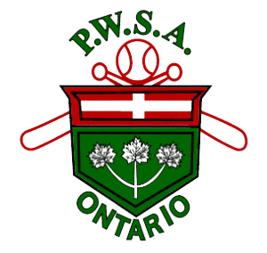

PWSA PERMISSION TO PLAY FOR 2025/2026 SEASON
This is NOT a Player Release
All PWSA sanctioned activities must adhere to all federal, provincial, municipal, PHU requirements and PWSA Return to Play/Tryout Protocols. The strictest requirements must be followed.

For players registered for the 2025 season, Permission to Play forms are valid until December 31, 2025. Players without permission do not have insurance coverage.
No player may participate in any PWSA sanctioned activity with a team other than their own 2025 team unless they have a release or properly executed Permission to Play form.
Players may NOT participate in any tryout with an Affiliated or Non-Recognized program until Labour Day (September 1, 2025)
A player who is under suspension is NOT eligible for Permission to Play unless they have prior written approval from the PWSA Discipline Board.

Surname Given Name(s)

of is granted permission to attend tryouts with
Team/ Association Name

Team/ Association Name

from

Authorized by: Phone #:
Please Print Name, Position & Phone # of Designated Executive Member

Signature - Designated Executive Member Date

Falsification of this form may result in a suspension of the player for up to 3 years as per PWSA regulations. The player is to retain the original copy. Please submit a photocopy for each tryout or sanctioned activity.

These forms must be available to the PWSA board if requested.

PWSA Player Movement / Tryout Policy
"Permission to Play" forms must be filled out and signed by a designated executive member of the player's current association/team and presented to the association/team for which the player wishes to try out before they are allowed on the field. Failure to comply will result in a minimum of 2 months' suspension for the offending player and/or head coach.

The Form is available at PWSA Form

PWSA TAMPERING POLICY

Policy is available on the PWSA website - PWSA-RULE-BOOK-2025_Final.pdf

