PWSA MRS User Guide

Table of Contents

Critical Registration Information……………………………………………………………………………………………..…2

New Player Registration………………………………………………………………………………………………………….…3

Returning Player Registration………………………………………………………………………………………………….…5

New Coach / Manager Registration…..……………………………………………………………………………………….6

Returning Coach / Manager Registration………………………….…………………………………………………….…8

New Association Contact Registration………………………………………………………………………………………10

Returning Association Contact Registration………………………………………………………………………………11

Payment Information………………………………..………………………………………………………………………………13

Contact Information..………………………………..………………………………………………………………………………13

CRITICAL REGISTRATION INFORMATION

While every field that a user completes is important, there are many key pieces of information that if left blank or entered incorrect will delay the completion of an individual registration, and not allow association contact to assign players, coaches, managers to teams.

PWSA Player Number | - the number assigned to the player, coach, manager  - You can look up the player number using the “Database Lookup” located on the main registration screen
Date Of Birth | - You must enter in YYYY-MM-DD format  - The birthdate translates into what division the registration can be allotted to, so it’s important to get it correct
Association | - Choose the association you belong to for 2023/2024. If you don’t select one, your association contact won’t be able to properly add you to their rosters, etc.  - Example: Whitby Eagles, Windsor Wildcats, etc
Coach NCCP Number | - Coaches must have this number  - You can look up your number on the Coach.ca website
Respect in Sport Number | - This is the number given to a player, parent, coach etc that has completed the Respect in Sport training.  - You can use training from another sport/activity, but you must enter a valid number
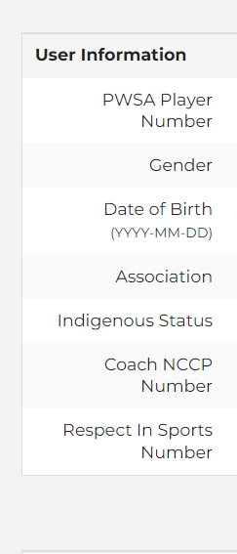

2023/2024 is the third year we are using online registration. The next series of pages explains how to register as a first-time user to the site, as well as the process for returning users. Please follow the process applicable to your situation.
PLAYER REGISTRATION

New Player Registration

Step 1: Go to https://register.pwsaontario.com/Account/Login

Step 2: Select “New user? Sign up here”
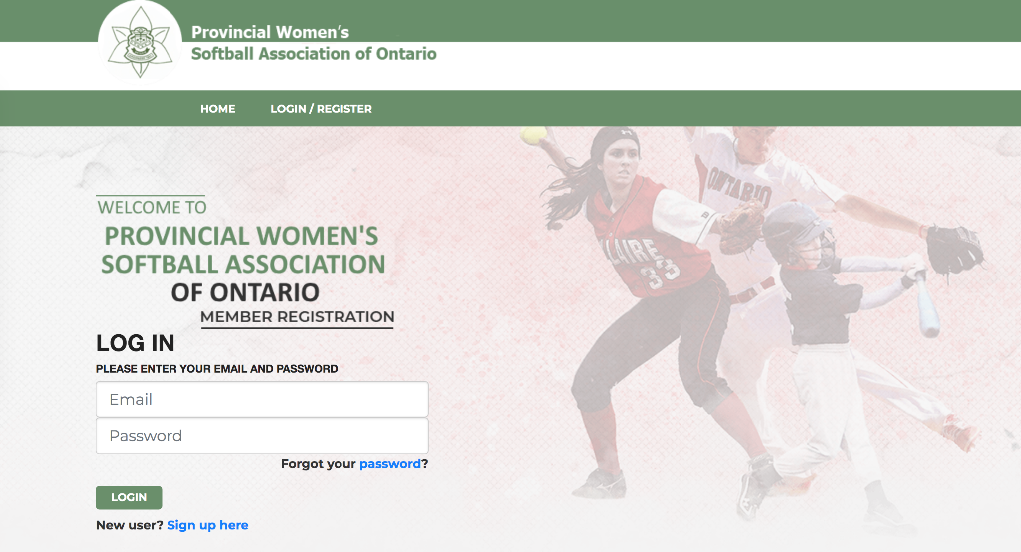

Step 3: Enter your information and check your email for your registration link. Please note: This email MUST be specific to the person registering. ONE EMAIL PER MEMBER.
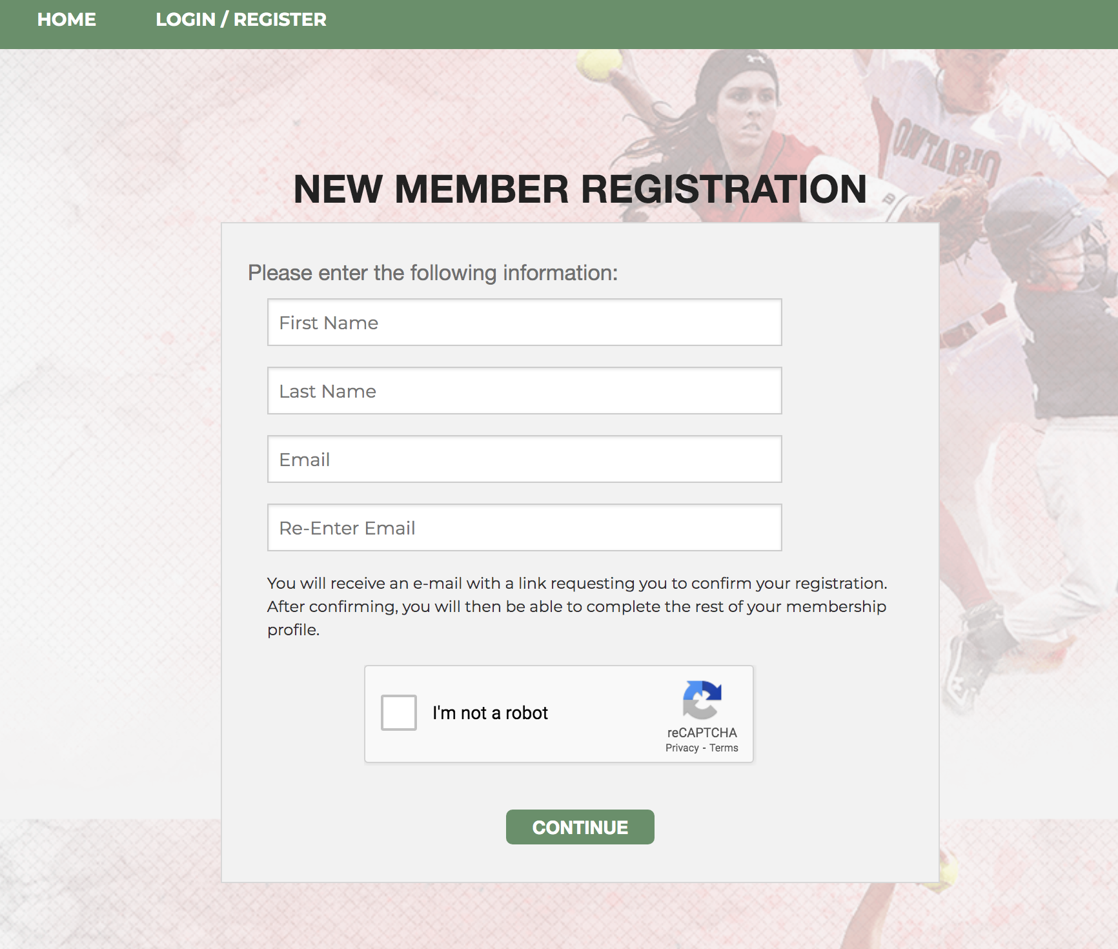

Step 4: Click the link in the registration email. Please ensure you check your junk mail. Please allow 5-10 minutes for the email to go through.
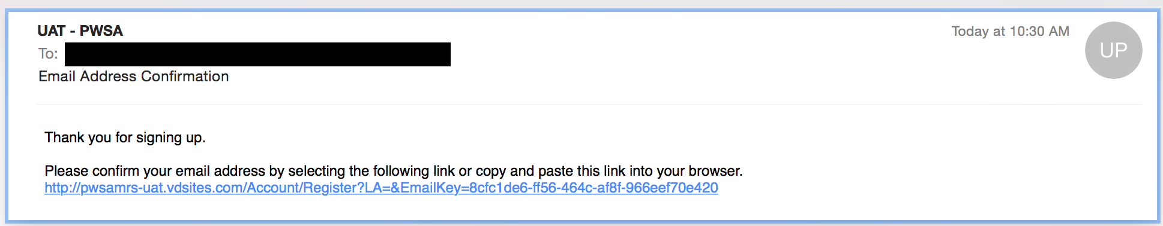

Step 5: Fill out the rest of the user information. Please note: the PWSA Player Number section is for all previous members. If you have not been a member of PWSA in the past, please leave this section blank. You can look up your PWSA Player Number by clicking the “Database lookup” link.

Step 6: Select your role as a player.

Step 7: Ensure you read and agree to all waivers.

Step 8: Complete payment via credit card or e-transfer. The email to send your e-transfer is payment@softballontario.ca

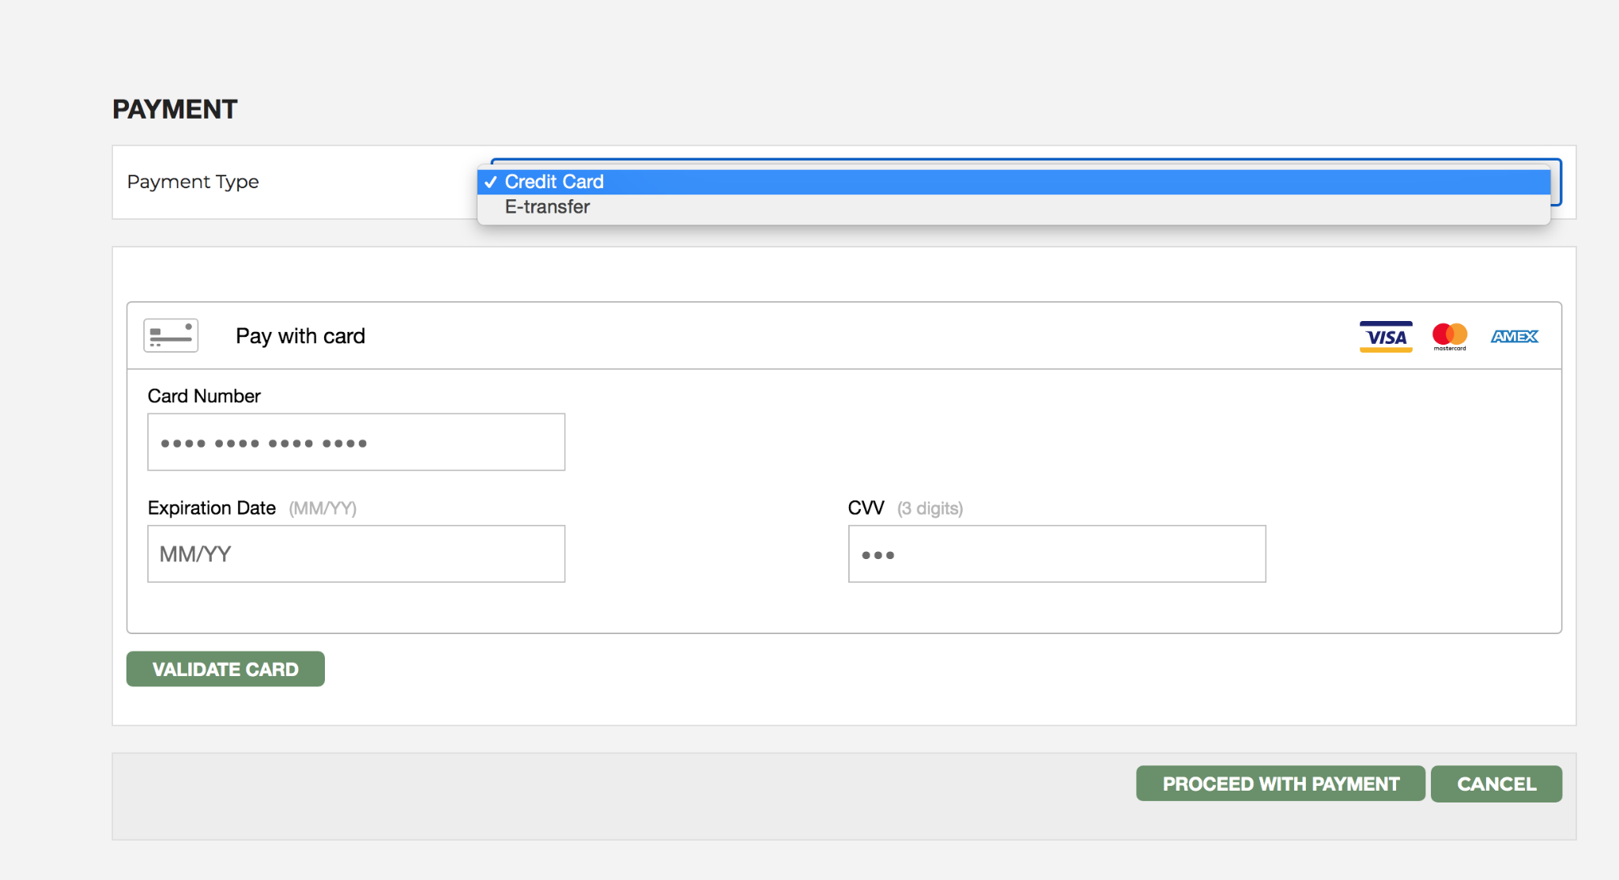

You are now a member!

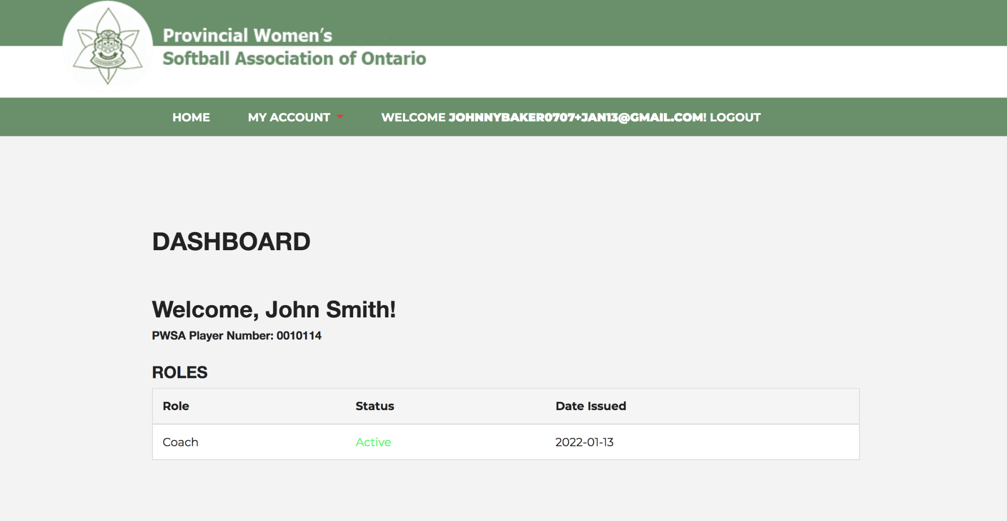

Returning Player Registration

Step 1: Go to https://register.pwsaontario.com/Account/Login

Step 2: Enter the e-mail address and password associated with your player account. This would be the login information you used previously. If you have forgotten your login password click the “forgot password” link. Then allow time for the system to send you a link to change your password. The link will be sent to the e-mail account you have registered with.

Step 3: Fill out the rest of the user information. If you do not remember your PWSA Player Number you can look up the applicable number using the “Database Lookup” link. You will need to know the e-mail address that you used to register in the past in order to retrieve your PWSA number.

Step 4: Select your role as a player. Select the applicable division. (i.e. U11, U13, U15 etc.) It is also important to pick the correct Tier. These steps will allow your coach/manager and/or association contact to “add” you to the team roster.

Step 5: Ensure you read and agree to all waivers.

Step 6: Complete payment via credit card or e-transfer. The email to send your e-transfer is payment@softballontario.ca

COACH/MANAGER REGISTRATION

New Coach/Manager Registration

Before you start, please ensure you have your NCCP # ready. If you do not have an NCCP #, go to thelocker.coach.ca, select “Don’t have an NCCP#? Create one now!” If you think you may have an NCCP #, but don’t remember, please select “Look up my NCCP#”. * An NCCP number is not required for the manager role.

Step 1: Go to https://register.pwsaontario.com/Account/Login

Step 2: Select “New user? Sign up here”

Step 3: Enter your information and check your email for your registration link. Please note: This email MUST be specific to the person registering. ONE EMAIL PER MEMBER.

Step 4: Click the link in the registration email. Please ensure you check your junk mail. Please allow 5-10 minutes for the email to go through.

Step 5: Fill out the rest of the user information. Please note: the PWSA Player Number section is for all previous players. If you are not a player, please bypass this section.

Step 6: Select your role as a coach/assistant coach.

Step 7: Ensure you read and agree to all waivers.

Step 8: Complete payment via credit card or e-transfer. The email to send your e-transfer is payment@softballontario.ca

You are now a member!

Returning Coach/Manager Registration

Step 1: Go to https://register.pwsaontario.com/Account/Login

Step 2: Enter the e-mail address and password associated with your coach account. This would be the login information you used previously. If you have forgotten your login password, click the “forgot password” link. Then allow time for the system to send you a link to change your password. The link will be sent to the e-mail account you have registered with.

Step 3: Fill out the rest of the user information. Please note: the PWSA Player Number section is for all previous players. If you are not a player, please bypass this section.

Step 4: Select your role as a coach/assistant coach.

Step 5: Ensure you read and agree to all waivers.

Step 6: Complete payment via credit card or e-transfer. The email to send your e-transfer is payment@softballontario.ca

ASSOCIATION CONTACT REGISTRATION

New Association Contact Registration

Step 1: Go to https://register.pwsaontario.com/Account/Login

Step 2: Select “New user? Sign up here”

Step 3: Enter your information and check your email for your registration link.

Step 4: Click the link in the registration email. Please ensure you check your junk mail. Please allow 5-10 minutes for the email to go through.

Step 5: Fill out the rest of the user information. Please note: the PWSA Player Number section is for all previous players. If you are not a player, please bypass this section. Please also type “n/a” in Coach NCCP# if you do not have one.

Step 6: Select your role as an association contact.

Step 7: Ensure you read and agree to all waivers.

Step 8: Complete payment via credit card or e-transfer. The email to send your e-transfer is payment@softballontario.ca

Step 9: Go to “Manage” and click “Teams”. From there, select “View/Edit” under Association and enter in all your information including Executive Members and the Constitution.

You are now a member!

Returning Association Contact

Step 1: Go to https://register.pwsaontario.com/Account/Login

Step 2: Enter the e-mail address and password associated with your coach account. This would be the login information you used previously. If you have forgotten your login password, click the “forgot password” link. Then allow time for the system to send you a link to change your password. The link will be sent to the e-mail account you have registered with.

Step 3: Fill out the rest of the user information. Please note: the PWSA Player Number section is for all previous players. If you are not a player, please bypass this section. Please also type “n/a” in Coach NCCP# if you do not have one.

Step 4: Select your role as an association contact.

Step 5: Ensure you read and agree to all waivers.

Step 6: Complete payment via credit card or e-transfer. The email to send your e-transfer is payment@softballontario.ca

Step 7: Go to “Manage” and click “Teams”. From there, select “View/Edit” under Association and enter in all your information including Executive Members and the Constitution.
To add your Executive Members, they will need to have an active profile for this season and have added the Board of Directors role to their profile. The BOD role has no charge for it, but all your Executive must create and register.

To add your Executive Members to this section, type into the search engine a part of their contact information.
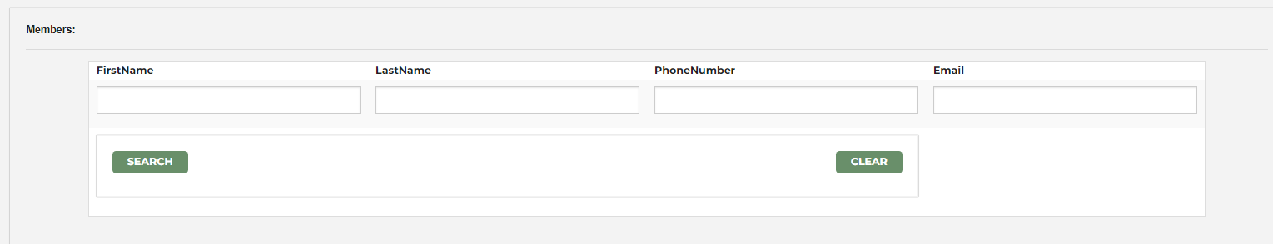

If they have added the role and your Association to their profile, their name should come up.
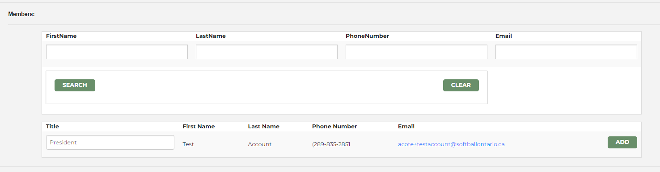

Once their information comes up, under the Title, fill this in with their Executive Role with your Association and then click add. The system has a security setting, if you are uploading quite a few members, please click update at the bottom of the page throughout this process to make sure that the page does not time out.
Also, when you are finished uploading your members, please click update to save all of your members.

PAYMENT INFORMATION

In order to complete any type of registration, payment of the applicable fee is required. There are two methods of paying a registration.
- Credit Card
- E-Transfer

When you are sending an e-transfer, you must send payment to payment@softballontario.ca . You also need to properly identify the incoming payment, so that our team reconciling funds received vs registrations understands who/what to allocate the monies too. You can do this by being descriptive on the site when advising you will be sending an e-transfer, and can do the same when you’re sending the monies from your financial institution. The more detail we have the easier it will be to quickly finalize the registration for you.

CONTACT OPTIONS

We are happy to try and assist you with any type of registration. You can also start with reaching out to your association contact. Chances are she/he has already encountered a similar issue and maybe able to resolve your roadblock quickly. If you are not sure who your association contact is, please consult your team coach/manager.

If a problem persists you can try contact us at info@softballontario.ca

We ask that you are patient and understand that our team may be fielding a number of similar questions from other members. We will reply to you as soon as possible. We may also ask your association contact to try and assist.

