MOTIONS – SPECIAL OPERATING RULES
SOR Motions will be voted on in several slate votes. Motion 1, 7, 19 and 21 were withdrawn. Motion 23 Amended. Motion 24 to be voted on separately.

Move to approve SOR Motions 2 - 6, 8 - 18, 20, 22, and 25 in one slate vote
Moved by: Jeff Ellsworth (PE) | Seconded by: Richie Connors (NS)

NOTICE OF MOTION #1
Submitted by: Softball Québec

REFERENCE : (Section, article, number, page, etc.)
Part One, Art. 1.1 Bid Procedures f) (p. 210)
WHEREAS (Article as currently written.)
f) Provinces/Territories who have communities bidding on a Championship must have had at least one (1) team from the Province or Territory participate in the Championship they are bidding on the year before the Championship. If there are no other bids, except from a P/T who hadn’t participated as stated above, then these bids can be considered after October 1st the year prior to the Championship
BE IT RESOLVED THAT (Motion. State whether revision, addition, deletion)
DELETION
RATIONALE
Removing the limitation will allow for more provinces to bid on Canadian Championships.
Softball Canada already has some difficulty finding host committees. This change will certainly help provinces who rarely host championships to show their interest in doing so and to bid on Canadian Championships.
For example, a province who is currently developing in a category may want to submit a bid without the stress of absolutely needing to send a team to Canadian Champioships the year prior.
It is also important to note that in categories like U15 and U17, hosting a Canadian Championship can spark interest and generate increased interest and motivation for the following year. It is therefore possible that a province is unable to send a team one year simply because they are preparing for the next year.
When a bid is presented more than a year before the championship, it is often difficult to know if at least one team will be participating the year prior to the championship you bid on. A bid can also be done 2 years in advance with the belief that a team while be participating but when it comes time, for varying reasons, the team doesn’t participate.
In our opinion, a province who wants to develop the sport shouldn’t be penalized because they were unable to present a team in a specific category. Penalizing a province by not allowing them to host an event that could help development in their region will harm the overall development of softball.
To conclude, we reiterate that Softball Canada needs to help provinces host Canadian Championships by offering more flexibility. By removing this rule, we give host committees the opportunity to better prepare their event and more time to secure sponsorships for the event.
FINANCIAL IMPLICATIONS (Softball Canada, Provincial/Territorial, Individual)
None for Softball Canada but a lot for a host committee who could be confirmed two years in advance allowing them to secure more sponsorships without the fear that Softball Canada will pull the plug one year before.
Final Recommendations: Withdrawn

NOTICE OF MOTION #2
Submitted by: Softball Canada Board of Directors

REFERENCE : (Section, article, number, page, etc.)

Part Two, Art. 1.1 Eligibility a) iii) (p. 213)

WHEREAS (Article as currently written.)
iii) Are at least fifteen (15) years of age as of January 1 of the current year in order to be eligible to participate in a Senior Canadian Championship
BE IT RESOLVED THAT (Motion. State whether revision, addition, deletion)
REVISION
iii) Are at least fifteen (15) years of age as of January 1 of the current year in order to be eligible to participate in a Men’s or Women’s Canadian Championship
RATIONALE
Housekeeping. We no longer refer to the Men’s and Women’s Canadian Championships as “Senior” events.

FINANCIAL IMPLICATIONS (Softball Canada, Provincial/Territorial, Individual)
None

Final Recommendations: Carried

NOTICE OF MOTION #3
Submitted by: Softball Canada Board of Directors

REFERENCE : (Section, article, number, page, etc.)
Part Three (SP), Art. 1.1 Introduction d) (p. 217)
WHEREAS (Article as currently written.)
d) The start date for the Men’s Championship would be Sunday concluding on Saturday for a 7 day event. The start date for the Women’s Championship would be on the Monday concluding on the Saturday for a 6 day event.
BE IT RESOLVED THAT (Motion. State whether revision, addition, deletion)
REVISION:
d) The start date for the Men’s and Women’s Championship would be Sunday concluding on Saturday for a 7 day event.

RATIONALE
Housekeeping. The Women’s Slo-Pitch Canadian Championship has been a 7 day event as requested by the teams since 2019.

FINANCIAL IMPLICATIONS (Softball Canada, Provincial/Territorial, Individual)
None
Final Recommendations: Carried

NOTICE OF MOTION #4
Submitted by: Softball Canada Board of Directors

REFERENCE : (Section, article, number, page, etc.)
Part Two, Art. 2.6 Provincial Non-Residents (Fast Pitch Only) a) i) (p. 215)
WHEREAS (Article as currently written.)
- i) In U23 Men’s/Women’s, all but one (1) player on any provincial/territorial representative team to a Canadian Championship must be a bona fide resident of that province/territory by the official residency date for the year of competition.
ii) In U20 Men’s, U19 Women’s, U23 Men’s/Women’s Championships, all but six (6) players, and only two of these will be allowed to be pitchers, on any territorial representative team to a Canadian Championship must be a bona fide resident of that territory by the official residency date for the year of competition, with the release of the Province/Territory that the player is registered with.
- In Men’s, Master Men’s and Women’s Canadian Championships, all but two (2) players, and only one of these will be allowed to be a pitcher, on any provincial/territorial representative team to a Canadian Championship must be a bona fide resident of that Province/Territory by the official residency date for the year of competition.
BE IT RESOLVED THAT (Motion. State whether revision, addition, deletion)
DELETE i) and REORDER ii) as a)
REVISION to b) In U23 Men’s, U23 Women’s, Men’s, Master Men’s and Women’s Canadian Championships, all but two (2) players, and only one of these will be allowed to be a pitcher, on any provincial/territorial representative team to a Canadian Championship must be a bona fide resident of that Province/Territory by the official residency date for the year of competition.
RATIONALE
There is low participation in the U23 Men’s and U23 Women’s age categories. Adding an additional provincial non-resident (“import”) may help more teams participate in these events.

FINANCIAL IMPLICATIONS (Softball Canada, Provincial/Territorial, Individual)
None
Final Recommendations: Carried

NOTICE OF MOTION #5
Submitted by: Softball Canada Board of Directors

REFERENCE : (Section, article, number, page, etc.)
Part Three (SP), Art. 1.2 a) Team Representation iv) (p. 217)
WHEREAS (Article as currently written.)
iv) When a Canadian Championship is hosted by a province/territory who has been given all-star status in the category presented, this hosting province/territory may participate in the Canadian Championship with two (2) all-star teams.
BE IT RESOLVED THAT (Motion. State whether revision, addition, deletion)
DELETE iv)
RATIONALE
Housekeeping. This SOR does not apply to Slo-Pitch as there are no provinces/territories with all-star status. Even if they did in the future, this SOR makes no sense as P/T’s are allowed to send up to four teams.
FINANCIAL IMPLICATIONS (Softball Canada, Provincial/Territorial, Individual)
None
Final Recommendations: Carried

NOTICE OF MOTION #6
Submitted by: Softball Canada Board of Directors

REFERENCE : (Section, article, number, page, etc.)
Part Three (SP), Art. 1.2 Participants a) Team Representation v) b) (p. 218)
WHEREAS (Article as currently written.)
b) At least eight (8) players from the championship roster are still on the current roster and in attendance. If the previous champion does not have eight (8) returning players, the provincial/territorial body can declare a Defending Champion.
BE IT RESOLVED THAT (Motion. State whether revision, addition, deletion)
REVISION
b) At least seven (7) players from the championship roster are still on the current roster and in attendance. If the previous champion does not have seven (7) returning players, the provincial/territorial body can declare their Provincial Champion (or top seeded team) as a Defending Champion.
RATIONALE
This reduces the amount of returning players from 8 to 7 and clarifies which team the provincial/territorial body can declare as Defending Champion. With the previous wording, the provincial/territorial body could designate any team as Defending Champion and could take advantage of pre-determined scheduling.
FINANCIAL IMPLICATIONS (Softball Canada, Provincial/Territorial, Individual)
None
Final Recommendations: Carried

NOTICE OF MOTION #7
Submitted by: Softball Saskatchewan

REFERENCE : (Section, article, number, page, etc.)
Part 3 SOR SP. Article 1, 1.2. Participants, c) playing Rosters, iv) Player Additions, f), page 219
WHEREAS (Article as currently written.)
Any team from Manitoba or Saskatchewan attending the Canadian slo-Pitch Championships can pick up to five (5) from each other’s Province with the release of the player’s home province. All releases must be handled as per the Softball Canada Guidelines.
BE IT RESOLVED THAT (Motion. State whether revision, addition, deletion)
REVISION:
Any team from Manitoba or Saskatchewan attending the Canadian Slo-Pitch Championships can pick up to eight (8) from each other’s Province with the release of the player’s home province. All releases must be handled as per the Softball Canada Guidelines
RATIONALE
It can cost $30,000 - $40,000 for a team to attend a Canadian Championship. The teams from the smaller provinces have a much smaller number of residents to choose from than the larger provinces and simply looking to be able to field the most competitive team possible at the Canadian Championships.

FINANCIAL IMPLICATIONS (Softball Canada, Provincial/Territorial, Individual)
NONE
Final Recommendations: Withdrawn

NOTICE OF MOTION #8
Submitted by: Softball Canada Board of Directors

REFERENCE : (Section, article, number, page, etc.)
Part Three (Slo-Pitch), Art. 2.1 Tournament Format b) Championship Round (p. 220)
Part Four (Fast Pitch), Art. 2.1 Tournament Format b) ii) Championship Round (p. 231)
WHEREAS (Article as currently written.)
b) Championship Round
In championships with 7, 8 or 9 teams, 6 teams will play in the championship round. The top 4 teams will have 2 “lives” and the next 2 teams will have a single “life”. In championships with 10 or more teams, 8 teams will play in the championship round. The top 4 teams will have 2 “lives” and the next 4 teams will have a single “life”.
BE IT RESOLVED THAT (Motion. State whether revision, addition, deletion)
REVISION
b) Championship Round
In championships with 7, 8 or 9 teams, 6 teams will play in the championship round. The top 2 teams will have 2 “lives” and the next 4 teams will have a single “life”. In championships with 10 or more teams, 8 teams will play in the championship round. The top 4 teams will have 2 “lives” and the next 4 teams will have a single “life”.
RATIONALE
Housekeeping. The wording in this SOR did not reflect what is applied in our Championship bracket on the following page. In a 6-team playoff bracket, only 2 teams have 2 lives and 4 teams have a single life. This applies to both Slo-Pitch and Fast Pitch.
FINANCIAL IMPLICATIONS (Softball Canada, Provincial/Territorial, Individual)
None
Final Recommendations: Carried

NOTICE OF MOTION #9
Submitted by: Softball Canada Board of Directors

REFERENCE : (Section, article, number, page, etc.)
Part Three (Slo-Pitch), Art. 2.1 Tournament Format c) ii) (p. 220)
Part Four (Fast Pitch), Art. 2.1 Tournament Format c) ii) (p. 231)
WHEREAS (Article as currently written.)
c) Ranking in the Qualifying Round
Final standings in the qualifying round shall be established using the following criteria:
- Won/Lost records. If still tied, then:
- Winners of games between tied teams NOTE: In order to use this criteria, all subject tied teams must have played each other and one team must have defeated all the teams they are tied with to be ranked higher. The remaining teams then revert back to i) and continue on.
BE IT RESOLVED THAT (Motion. State whether revision, addition, deletion)
REVISION
c) Ranking in the Qualifying Round
Final standings in the qualifying round shall be established using the following criteria and will revert back to i) after each criterion if the tie is broken.
- Won/Lost records. If still tied, then:
- Winners of games between tied teams NOTE: In order to use this criteria, all subject tied teams must have played each other and one team must have defeated all the teams they are tied with to be ranked higher. If still tied, then:
RATIONALE
The previous SOR was unclear on when teams reverted back to their head-to-head result. This clarifies that it is after each individual criterion if the tie is broken.
FINANCIAL IMPLICATIONS (Softball Canada, Provincial/Territorial, Individual)
None
Final Recommendations: Carried

NOTICE OF MOTION #10
Submitted by: Softball Canada Board of Directors

REFERENCE : (Section, article, number, page, etc.)
Part Three (SP), Art. 2.1 Tournament Format c) iii) NOTE (p. 220)
WHEREAS (Article as currently written.)
NOTE: When using criteria iii) full team records of the entire team records of the entire qualifying round, and only 4,5,6 etc. FULL innings in 4½, 5½, 6½ etc. inning games are to be used.
BE IT RESOLVED THAT (Motion. State whether revision, addition, deletion)
DELETION
RATIONALE
This change was previously made in Fast Pitch and has worked well. Tiebreaking criteria should be based on the game’s final score, not the score after the last completed full inning. This removes confusion for teams who gain or lose plus/minus, runs scored and runs against in the top of the last inning.
FINANCIAL IMPLICATIONS (Softball Canada, Provincial/Territorial, Individual)
None
Final Recommendations: Carried

NOTICE OF MOTION #11
Submitted by: Softball Canada Board of Directors

REFERENCE : (Section, article, number, page, etc.)
Part Three (SP), Art. 2.1 Tournament Format c) iii) a) and b) (p. 220)
WHEREAS (Article as currently written.)
a) If teams are still tied within iii), then the total runs scored in all games will be used. If still tied, then:
b) The least (fewest) amount of runs scored against in all games will be used. If still tied, then:
BE IT RESOLVED THAT (Motion. State whether revision, addition, deletion)
REVISION
iv) The least (fewest) amount of runs scored against in all games will be used. If still tied, then:
v) The total runs scored in all games will be used. If still tied, then:
Renumber a-b-c) to iv-v-vi)
RATIONALE
Inversing a) and b) to consider runs against ahead of runs scored in the criteria. This lines up with WBSC tie-breaking criteria and places a greater emphasis on preventing defensive runs as opposed to running up the score.
Renumbering because a-b-c should not be on a sub-level under iii)
FINANCIAL IMPLICATIONS (Softball Canada, Provincial/Territorial, Individual)
None
Final Recommendations: Carried

NOTICE OF MOTION #12
Submitted by: Canadian Championship
REFERENCE : (Section, article, number, page, etc.)
Part Three (Slo-Pitch), Art. 2.2 Model Draws a) Championship Round (p. 221)
WHEREAS (Article as currently written.)
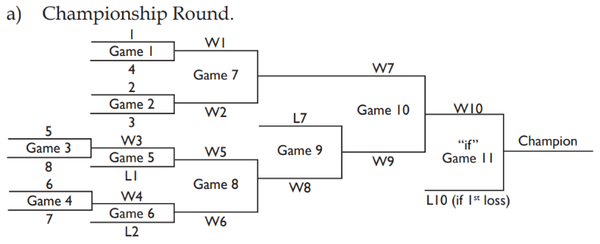

BE IT RESOLVED THAT (Motion. State whether revision, addition, deletion)
ADDITION
b) Championship Round
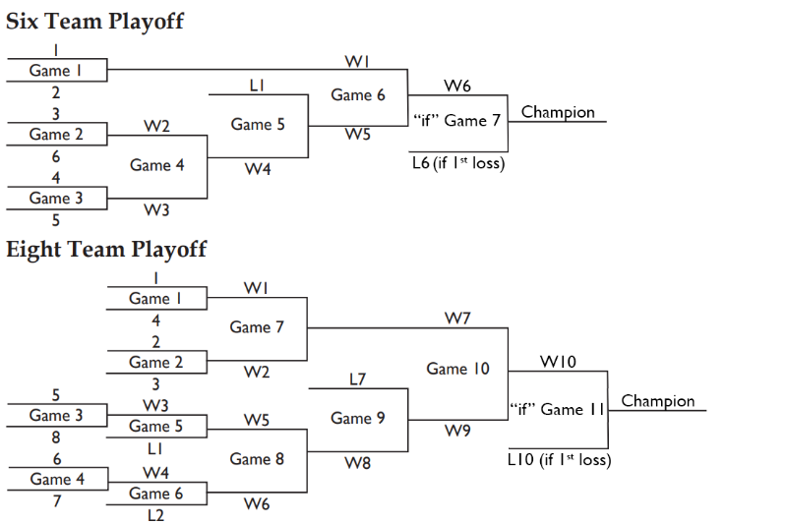

RATIONALE
Housekeeping. Adding the 6-team playoff bracket that is referred to in SOR Part Three, Art. 2.1 b)
FINANCIAL IMPLICATIONS (Softball Canada, Provincial/Territorial, Individual)
None
Final Recommendations: Carried

NOTICE OF MOTION #13
Submitted by: Softball Canada Board of Directors

REFERENCE : (Section, article, number, page, etc.)
Part Three, Art. 2.5 Awards e) (p. 222)
WHEREAS (Article as currently written.)
e) In order for players to qualify for the final standings at bat or on the mound, the following will apply:
At bat: A player must have gone to bat at least 2.5 times the number of games the team has played, rounded to the highest whole number (with any activity at bat counting for a “time at bat”).
On the mound: A pitcher must have pitched in more than 8 innings (8 1/3 innings is sufficient to qualify).
BE IT RESOLVED THAT (Motion. State whether revision, addition, deletion)
REVISION
e) In order for players to qualify for individual awards, the following will apply:
At bat: A player must have at least 2.5 plate appearances times the number of games the team has played, rounded to the highest whole number

RATIONALE
Housekeeping. This clarifies that the criteria is for individual awards (not “final standings”), the wording is simplified to refer to plate appearances, and the “On the mound” part is deleted as we no longer have a “Top Pitcher” award in Slo-Pitch – it was replaced with a “Top Defensive Player” award several years ago.
FINANCIAL IMPLICATIONS (Softball Canada, Provincial/Territorial, Individual)
None
Final Recommendations: Carried

NOTICE OF MOTION #14
Submitted by: Softball Canada Board of Directors

REFERENCE : (Section, article, number, page, etc.)
Part Three, Art. 2.6 Official Softball c) (p. 222)
WHEREAS (Article as currently written.)
c) The official and exclusive softball for the Women’s Canadian Championship will be the Rawlings Super Green Dot YSX11RSC3 (COR 44).
BE IT RESOLVED THAT (Motion. State whether revision, addition, deletion)
REVISION
c) The official and exclusive softball for the Women’s Canadian Championship will be the Rawlings 11” Hot Dot SBC11HDSY or Rawlings Super Green Dot YSX11RSC3.
RATIONALE
Housekeeping. Change of the official Women’s Slo-Pitch ball to the 11” Hot Dot will be within the next few years.
FINANCIAL IMPLICATIONS (Softball Canada, Provincial/Territorial, Individual)
None
Final Recommendations: Carried

NOTICE OF MOTION #15
Submitted by: Softball Canada Board of Directors

REFERENCE : (Section, article, number, page, etc.)
Part Three (SP), Art. 2.7 c) Bats v) (p. 224)
WHEREAS (Article as currently written.)
v) Any bat failing inspection will be confiscated by the Softball Canada representative, without prejudice, for the duration of the tournament and will be returned to the owner team after the owner team’s final game.
BE IT RESOLVED THAT (Motion. State whether revision, addition, deletion)
DELETION
RATIONALE
Housekeeping. Softball Canada no longer confiscates bats.
FINANCIAL IMPLICATIONS (Softball Canada, Provincial/Territorial, Individual)
Removes the risk of Softball Canada incurring costs of replacing bats if they are lost after being confiscated.
Final Recommendations: Carried

NOTICE OF MOTION #16
Submitted by: Softball Canada Board of Directors

REFERENCE : (Section, article, number, page, etc.)
Part Three (SP), Art. 2.7 c) Bats vii) (p. 224)
WHEREAS (Article as currently written.)
vii) Any player using a bat that was not inspected or has failed inspection and/or approval, shall have the bat confiscated and will be ejected for the remainder of the tournament.
BE IT RESOLVED THAT (Motion. State whether revision, addition, deletion)
REVISION
vii) Any player using a bat that was not inspected or has failed inspection and/or approval will be ejected for the remainder of the tournament.
RATIONALE
Housekeeping. Softball Canada no longer confiscates bats.
FINANCIAL IMPLICATIONS (Softball Canada, Provincial/Territorial, Individual)
None
Final Recommendations: Carried

NOTICE OF MOTION #17
Submitted by: Softball Canada Board of Directors

REFERENCE : (Section, article, number, page, etc.)
Part Four (Fast Pitch), Art. 1.2 Participants a) Team Representation i) (p. 227)
WHEREAS (Article as currently written.)
i) Canadian Championship events will be hosted ranging from five to seven days, with the maximum number of teams dependent on the host capacity.
BE IT RESOLVED THAT (Motion. State whether revision, addition, deletion)
REVISION
i) Canadian Championship events will be hosted ranging from five to six days, with the maximum number of teams dependent on the host capacity.
RATIONALE
Housekeeping. Fast Pitch Championships are always 5 or 6 days and never 7 based on feedback from hosts/teams.
FINANCIAL IMPLICATIONS (Softball Canada, Provincial/Territorial, Individual)
None.
Final Recommendations: Carried

NOTICE OF MOTION #18
Submitted by: Softball Canada Board of Directors

REFERENCE : (Section, article, number, page, etc.)
Part Four (Fast Pitch), Art. 1.2 a) Team Representation v) (b) (p. 227)
WHEREAS (Article as currently written.)
(b) At least eight (8) players from the championship roster are still on the current roster and in attendance except for the U23 level of competition where it is acceptable for seven (7) players to have been on the championship roster and the U15, U17, U19 and U20 level of competition where provincial/territorial bodies can declare a Defending Champion if the previous champion does not have seven (7) returning players.
BE IT RESOLVED THAT (Motion. State whether revision, addition, deletion)
REVISION
(b) At least seven (7) players from the championship roster are still on the current roster and in attendance. If the previous champion does not have seven (7) returning players, the provincial/territorial body can declare their Provincial Champion (or top seeded team) as Defending Champion.
RATIONALE
This reduces the amount of returning players from 8 to 7 in Men’s and Women’s categories and clarifies which team the provincial/territorial body can declare as Defending Champion. With the previous wording, the provincial/territorial body could designate any team as Defending Champion and could take advantage of pre-determined scheduling.
FINANCIAL IMPLICATIONS (Softball Canada, Provincial/Territorial, Individual)
None.
Final Recommendations: Carried

NOTICE OF MOTION #19
Submitted by: Softball Saskatchewan

REFERENCE : (Section, article, number, page, etc.)
SOR FP: Article 1, 1.2 Participants, c) Playing Rosters, i) Roster size, page 228

WHEREAS (Article as currently written.)
Playing Rosters
Team roster sizes will be as follows:
Players (including pick-ups) Minimum 11 Maximum 17

BE IT RESOLVED THAT (Motion. State whether revision, addition, deletion)
Revision: Add exception for Men’s and Women’s to be Maximum 18
RATIONALE
By increasing the number of players on a roster allows flexibility for players and teams. At this age many players struggle to commit to a team due to family, job and other competing commitments. This change would be beneficial to teams and ultimately the game by allowing more flexibility in the rosters.

FINANCIAL IMPLICATIONS (Softball Canada, Provincial/Territorial, Individual)
NONE

Final Recommendations: Withdrawn

NOTICE OF MOTION #20
Submitted by: Softball Saskatchewan

REFERENCE : (Section, article, number, page, etc.)
SOR FP: Article 1, 1.2 Participants, c), ii All-Star Rosters b), page 228

WHEREAS (Article as currently written.)
All-Star Rosters
b) The following provinces/territories have been allowed All-Star status in all categories:
7. Saskatchewan (except U19 and U20 categories)

BE IT RESOLVED THAT (Motion. State whether revision, addition, deletion)
Deletion of only: (Except U19 and U20 categories)
RATIONALE
Should we wish to utilize the All-Star status granted to us, these are the most likely age groups where we would utilize this rule.

FINANCIAL IMPLICATIONS (Softball Canada, Provincial/Territorial, Individual)
NONE

Final Recommendations: Carried

NOTICE OF MOTION #21
Submitted by: Softball Canada Board of Directors

REFERENCE : (Section, article, number, page, etc.)
Part Four (Fast Pitch), Art. 2.1 Tournament Format c) Ranking in the Qualifying Round (p. 231)
WHEREAS (Article as currently written.)
c) Ranking in the Qualifying Round
Final standings in the qualifying round shall be established using the following criteria:
- Won/Lost records. If still tied, then:
- Winners of games between tied teams NOTE: In order to use this criteria, all subject tied teams must have played each other and one team must have defeated all the teams they are tied with to be ranked higher. The remaining teams then revert back to i) and continue on.
- Difference PLUS or MINUS of total runs scored, with a limit of 7 PLUS or MINUS per game allowed.
- If teams are still tied within iii) the least (fewest) amount of runs scored against in all games will be used. If still tied, then:
- The total runs scored in all games, with a maximum of 10 runs scored per game, will be used. If still tied then:
- Positions will be settled by a coin toss.
BE IT RESOLVED THAT (Motion. State whether revision, addition, deletion)
c) Ranking in the Qualifying Round
Final standings in the qualifying round shall be established using the following criteria:
i) Won/Lost records. If still tied, then:
ii) Winners of games between tied teams NOTE: In order to use this criteria, all subject tied teams must have played each other and one team must have defeated all the teams they are tied with to be ranked higher. The remaining teams then revert back to i) and continue on.
iii) Least (fewest) runs scored against in the games among the tied teams. If still tied, then:
iv) Least (fewest) amount of runs scored against in all games will be used. If still tied, then:
v) Positions will be settled by a coin toss.
RATIONALE
Alignment with the WBSC and Canada Games tiebreaking criteria which no longer uses plus/minus and focuses on runs against instead of runs scored to break ties. The limit of 7 PLUS or MINUS and 10 runs scored created significant confusion for participants and fans when they looked at standings and tiebreaking criteria.
FINANCIAL IMPLICATIONS (Softball Canada, Provincial/Territorial, Individual)
None.
Final Recommendations: Withdrawn

NOTICE OF MOTION #22
Submitted by: Softball Canada Board of Directors
REFERENCE : (Section, article, number, page, etc.)
Part Four (Fast Pitch), Art. 2.2 Model Draws b) Championship Round (p. 232)
WHEREAS (Article as currently written.)
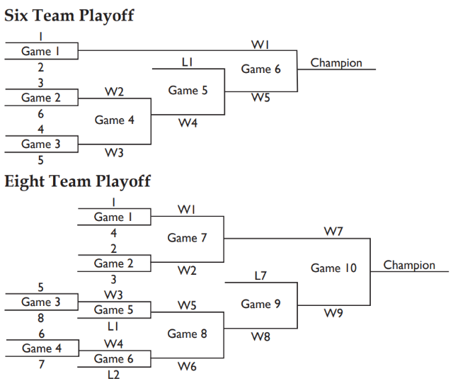

BE IT RESOLVED THAT (Motion. State whether revision, addition, deletion)
ADDITION
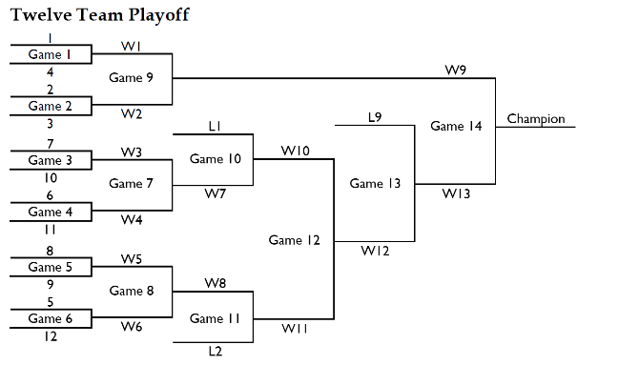

RATIONALE
Softball Canada has started using a twelve-team playoff format in certain categories with a high number of registered teams. This playoff format allows more teams to qualify for the playoff round, and is especially a good alternative in events that require a modified round robin in the preliminary round.
FINANCIAL IMPLICATIONS (Softball Canada, Provincial/Territorial, Individual)
None.
Final Recommendations: Carried

NOTICE OF MOTION #23
Submitted by: Softball Canada Board of Directors

Moved by: Dennis Marchiori (NT) | Seconded by: Hillary Pineau (NB)
REFERENCE : (Section, article, number, page, etc.)
Part Four (Fast Pitch), Art. 2.5 Awards e) (p. 233)
WHEREAS (Article as currently written.)
e) In order for players to qualify for the final standings at bat or on the mound, the following will apply:
At bat: A player must have gone to bat at least 2.5 times the number of games the team has played, rounded to the highest whole number (with any activity at bat counting for a “time at bat”).
On the mound: A pitcher must have pitched in more than 15 innings (15 1/3 innings is sufficient to qualify).
BE IT RESOLVED THAT (Motion. State whether revision, addition, deletion)
REVISION
e) In order for players to qualify for individual awards, the following will apply:
At bat: A player must have at least 2 plate appearances times the number of games the team has played, rounded to the highest whole number
In the circle: A pitcher must have pitched in 10 innings or more. more than 2 innings per team game played.
RATIONALE
This clarifies that the criteria is for individual awards (not “final standings”) and the wording is simplified to match current softball terminology. Players in some age categories had a difficult time reaching the previous minimums to qualify for awards because of a varying amount of preliminary round games depending on the number of teams entered. The new minimums are now tied to the amount of games played. There is also a slight reduction in plate appearances to allow more athletes to reach the minimum.
FINANCIAL IMPLICATIONS (Softball Canada, Provincial/Territorial, Individual)
None.
Final Recommendations: Carried (as amended)

NOTICE OF MOTION #24
Submitted by: Softball Canada Board of Directors

Moved by: Jackie Dugger (BOD) | Seconded by: Jason Ranchoux (BC)
REFERENCE : (Section, article, number, page, etc.)
Part Four (Fast Pitch), Art. 2.7 Dress and Equipment a) Uniforms ii) (p. 234)
WHEREAS (Article as currently written.)
ii) Coaches appearing on the field must wear uniforms identical (similar) to the players or any combination of dress shorts, slacks or track pants and shirts as near to the team colours as possible in all categories and Coaches’ footwear must be completely closed in (no sandals, crocs or similar footwear permitted). Both coaches are required to be dressed in similar fashion.
BE IT RESOLVED THAT (Motion. State whether revision, addition, deletion)
ADDITION
EXCEPTION: In the U23 Men’s and Men’s categories no shorts are allowed.
RATIONALE
With an increase in exposure/interest in the Men’s game, coaches should look more professional. The coach dress code in these categories has become an issue with some coaches wearing a combination of shorts and pants in the same game and it does not look professional. This was previously discussed and agreed to in a previous Canadian Championship Workshop but had not been presented as an SOR motion. This also aligns with WBSC regulations.
FINANCIAL IMPLICATIONS (Softball Canada, Provincial/Territorial, Individual)
None.
Final Recommendations: Carried

NOTICE OF MOTION #25
Submitted by: _Board of Directors/ODC__

REFERENCE : (Section, article, number, page, etc.)
Part Four – Canadian Fast Pitch Championship Play, Art. 2.7 Dress and Equipment

WHEREAS (Article as currently written.)
BE IT RESOLVED THAT (Motion. State whether revision, addition, deletion)
ADDITION
2.7 d) Bat Compression Test
Bat compression testing will be conducted at the U20 Men’s, U23 Men’s, Men’s and Master Men’s events on an annual basis. Failure to meet the bat compression test will result in the bat being an illegal bat and not permitted for use at the Canadian Championships. Bats approved for use will be marked, and any bat used that is not so marked will be considered an illegal bat.
Note - The protocol that will be followed to determine whether bats are suitable for play at the Canadian Championships will be available on the Softball Canada website. All bats will be compression tested to the current WBSC standards. If the bat passes compression testing, it will be approved for Canadian Championship play regardless of certification stamp(s).
RATIONALE
This motion follows recommendations made by USA Softball, the ISC and Men’s Fast Pitch athletes. Men’s Fast Pitch bats are not in high production and old stock is dwindling; most bats currently being used are 10-15 years old. Newer model bats are no longer made for the Men’s Fast Pitch game and preference is given to past models that have much more durability. Due to current market demand, manufacturers are building high-performance Slo-Pitch bats that are less durable or light weight female Fast Pitch bats, neither of which are very suitable for Men’s Fast Pitch. The compression test is to ensure the bat meets standards. If a bat can pass the standards, we are recommending it to be used regardless of the stamp on the bat.
FINANCIAL IMPLICATIONS (Softball Canada, Provincial/Territorial, Individual)
None Known.
Final Recommendations: Carried

