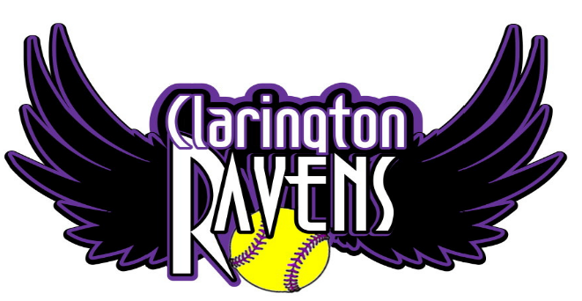

There’s a new team in town!

Introducing the Clarington Ravens.

We are holding tryouts for our 2018 season. We are looking for girls born in 2004 and 2005 to join us for our inaugural year. We have a great coaching team to ensure our girls have a competitive year full of hard work and fun.

Tryouts

6:30pm start

September 13, 14, 19, 20

Soper Park – Bowmanville
133 Simpson Avenue, Bowmanville

Coaching Highlights

Field Specialist: Sommer West
Batting and Catcher Coach: Tara Mowder
Pitching Coach: Kendra Medwedchuk
Head Coaches: To be announced.

** please come 15 mins early to register.

Check us out on facebook or email us at: clarington.ravens@gmail.com

