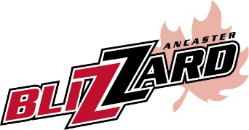
The Ancaster Blizzard Girls Rep program will be hosting tryouts for Squirt, Novice, Bantam 1 & 2, and Midget divisions. Please see below for Coaches information and tryout dates.
DIVISION COACH EMAIL ADDRESS
Squirt TBD
Novice Scott Ranney s_dranney@yahoo.ca
Bantam 1 Ron & Pam Korpan rpkorpan@gmail.com
Bantam 2 TBD
Midget Michael Carnegie mcarnegie@taylorleibow.com
Intermediate Chris Brownell lbrownell@cogeco.ca
Squirt (2005/2006)
TBD
Novice (2003/2004)
Monday, September 12, 2016, 6:00-8:00pm at Ancaster Community Centre #3
Tuesday, September 13, 2016, 6:00-8:00pm at Ancaster Community Centre #3
Bantam (2001/2002)
Monday, September 5, 2016, 1:00-3:00pm at Ancaster Community Centre #1
Tuesday, September 6, 2016, 6:00-8:00pm at Ancaster Community Centre #1
Saturday, September 10, 2016, 10:00am-12:00pm at James Smith Park
Midget (1999/2000)
Wednesday, September 7, 2016, 8:00-10:00pm at Ancaster Community Centre #1
Friday, September 9, 2016, 6:00-8:00pm at James Smith Park
Sunday, September 11, 2016, 6:00pm-8:00pm at Ancaster Community Centre #3
Tuesday, September 13, 2016, 6:00-8:00pm at Ancaster Community Centre #1
If you have any questions about a particular team, please contact the respective coach directly. If you are interested in coaching a team, or have questions about our program, please contact Bernie Anstett at 905-975-1060 or by email at bernie.anstett@gmail.com

