PWSA U18 Midget I Grands

HOTEL LISTINGS

1. Holiday Inn Oakville Centre
Rate: $127
Room: 2 Double Standard
Call: 905-842-5000
Includes: Full buffet breakfast for up to 4 people

2. Marriott

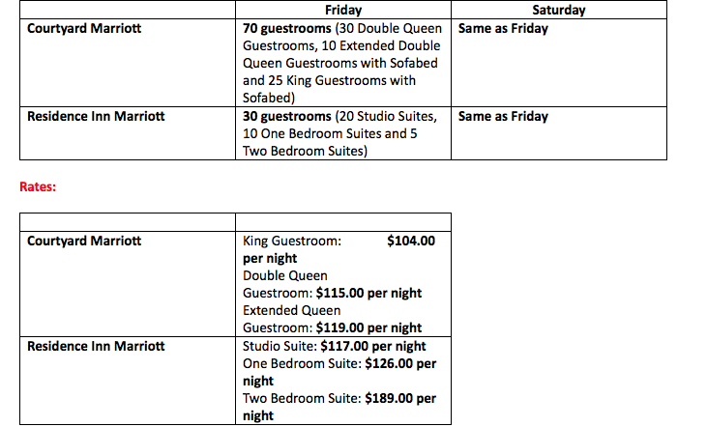

CHELSEA DOUCETTE
Dual Property Sales Manager
* call her direct line now. "905-363-3682 to book their teams and I will take care of the reservations for them".

Courtyard and Residence Inn by Marriott Mississauga Meadowvale
7015, 7005 Century Avenue
Mississauga, ON L5N 7K2
o 905-363-3682

3. Admiral Inn Mississauga
Rate Details: Standard Guest rooms (1 King Bed or 2 Queen)

Rate: $129.95+taxes – per room/per night

GUEST ROOM RESERVATIONS
Reservations can be made by (please state MSW Hurricanes Midget 1):
Anna Hollas – Regional Director of Sales
Direct: (647) 282-2066
E-mail: ahollas@admiralinn.com
THE FOLLOWING HOTEL AMENITIES & SERVICES INCLUDE:
- Daily Full Hot Breakfast Buffet * Ample Parking
- Wireless High-Speed Internet *Local Calls
- Daily newspaper *24-Hour Business Centre
- Usage of our Indoor Salt Water Swimming Pool, Hot-Tub, Fitness Centre and Sauna
PLEASE NOTE: PWSA Midget 1 Provincial Grands – July 14-16, 2017 – deadline to make reservations is June 14, 2016

4. Hilton Garden Inn Toronto/Mississauga
Rate: $139/night plus tax
Mandy Multani, Sales Manager
100 Traders Boulevard
Mississauga, ON L4Z 2H7
Main Phone Number: 905-890-9110
Mobile Phone Number: 647-328-9817
Direct Phone Number: 905-507-5471
mandy.multani2@hilton.com
www.torontomississauga.hgi.com

5. Homewood Suites by Hilton Toronto-Mississauga
Carolyn Halliday | Sales and Catering Coordinator
6430 Edwards Blvd., Mississauga, ON L5T 2Y3
Tel: 905-564-5529 x| Fax: 905-564-5236
Email: carolyn.halliday@hilton.com
Rate $154 plus tax – King Studio Suite and King 1 Bedroom Suite

